**PRACTICAL 9 : Light, Humidity & Temperature Monitoring**

**Aim :** To measure and display light intensity, humidity and temperature using respective sensors.

**Overview :**

This project integrates multiple sensors to measure light intensity, humidity and temperature. The collected data is displayed on an output device. It introduces multi-sensor interfacing and demonstrates how environmental monitoring can be implemented in IoT applications.

**Materials Required :**

* Arduino Uno R3
* 250 kΩ Potentiometer
* Temperature Sensor (TMP36)
* Ambient Light Sensor (Phototransistor)
* 3 x 1 kΩ Resistor
* Wifi Module (ESP8266)
* Breadboard Small
* Jumper Wires
* Arduino IDE (Installed on your Computer)

**Circuit Connection and Steps :**

1. **Powering Components :** Connect the **VCC** of all sensors and the ESP8266 to **5V**, except the ESP8266 **(VCC & CH_PD → 3.3V)**. Ensure all **GND** pins are connected to a common ground.
2. **Sensor Connections :**
   * The **LM35 temperature sensor** outputs data from its **OUT pin to A0** of the Arduino.
   * The **humidity sensor (potentiometer)** has its middle pin connected to **A1** for analog readings.
   * The **LDR (light sensor)** connects one leg to **A2**, the other to **5V**, with a **10kΩ pull-down resistor to GND** for stability.
3. **ESP8266 Communication :**
   * Connect the **ESP8266 TX to Arduino RX** through a **level shifter** for proper voltage handling.
   * Connect the **ESP8266 RX to Arduino TX** directly.
   * Pull **CH_PD high** by connecting it to **3.3V** to enable the module.

**Circuit Diagram :**

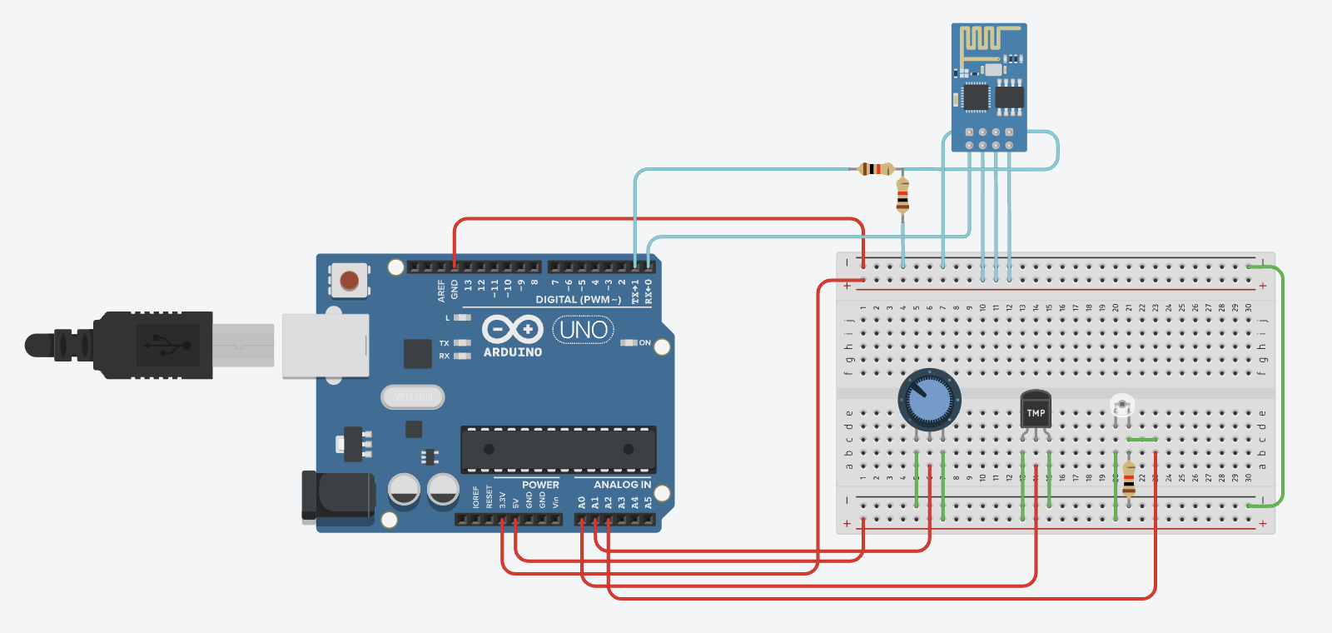

**Schematic Diagram :**

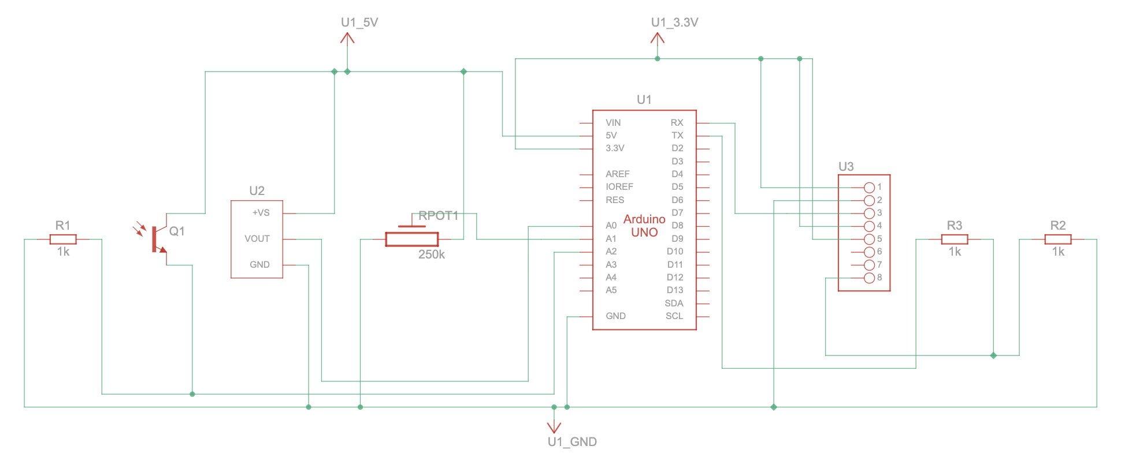

**Code :**

// WiFi Credentials

String ssid = "Simulator Wifi";

String password = "";

// ThingSpeak API Configuration

String host = "api.thingspeak.com";

const int httpPort = 80;

String apiKey = "YE76IRAW2UVM7LI5";

String endpoint = "/update?api_key=" + apiKey;

// Sensor Pin Configuration

const int tempPin = A0;

const int humidityPin = A1;

const int lightPin = A2;

void setup() {

Serial.begin(115200);

Serial.println("AT");

delay(500);

// Connect to WiFi

Serial.println("AT+CWJAP=\"" + ssid + "\",\"" + password + "\"");

delay(500);

// Establish TCP Connection

Serial.println("AT+CIPSTART=\"TCP\",\"" + host + "\"," + String(httpPort));

delay(500);

}

void loop() {

// Read sensor data

float temperature = ((analogRead(tempPin) * 0.0048828125) - 0.5) * 100;

float humidity = map(analogRead(humidityPin), 0, 1023, 0, 100);

float lightIntensity = map(analogRead(lightPin), 0, 471, 0, 100);

// Construct HTTP GET request

String httpRequest = "GET " + endpoint + "&field1=" + String(lightIntensity) +

"&field2=" + String(temperature) + "&field3=" + String(humidity) +

" HTTP/1.1\r\nHOST: " + host + "\r\n";

// Send data to ThingSpeak

Serial.println("AT+CIPSEND=" + String(httpRequest.length()));

delay(500);

Serial.println(httpRequest);

delay(1000);

}

**Results :**

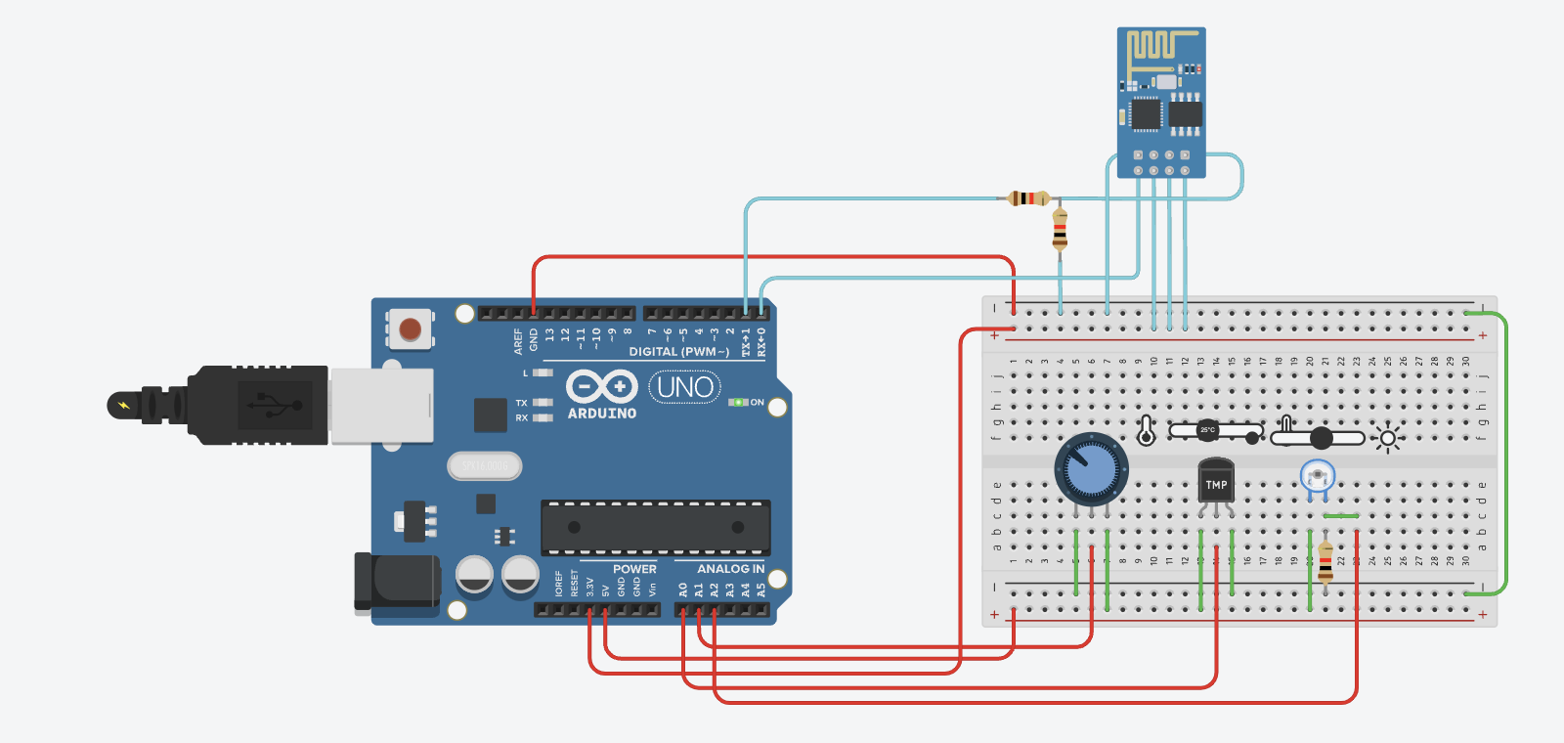

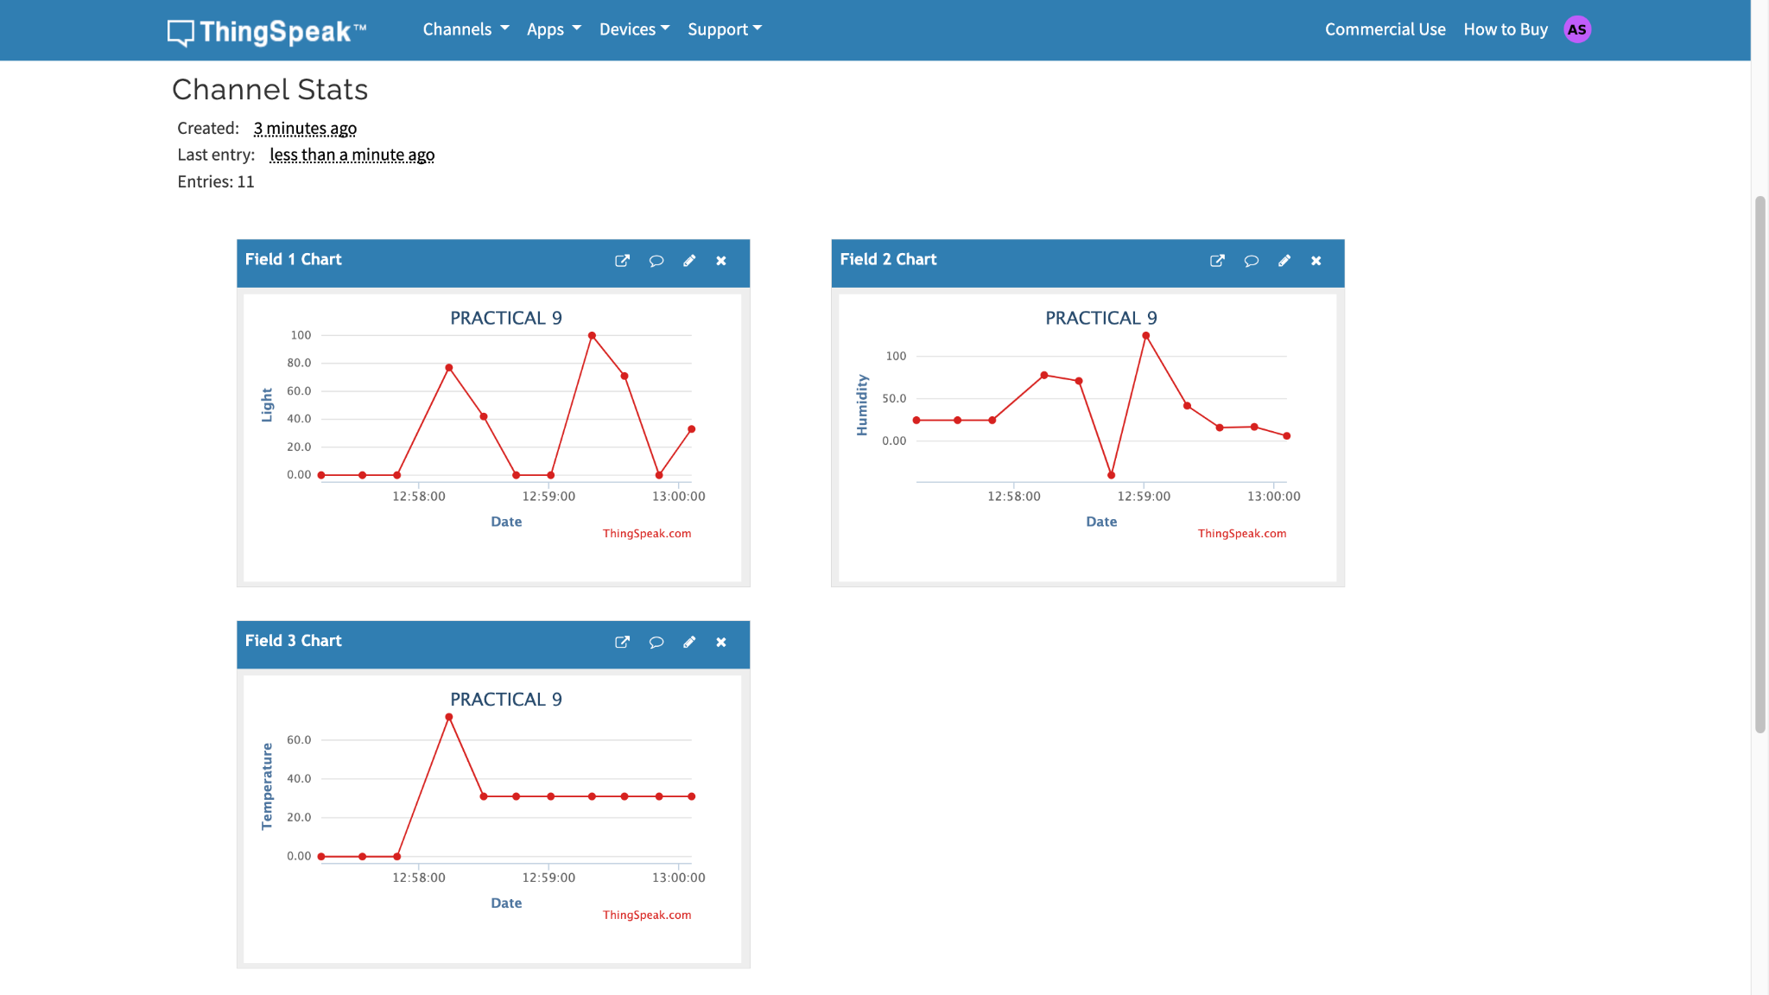

**Conclusion :**

The multi-sensor project successfully measures light intensity, humidity and temperature, showcasing the integration of multiple sensors with Arduino. It emphasizes real-time environmental data collection, which is crucial for applications in smart agriculture, weather monitoring and automated control systems.